saqarTvelos teqnikuri
universiteti

monacemTa bazebis marTvis sistemebi

kursi III

jgufi : 108050

salome tabataZe

Tema : restorani

monacemTa bazis Seqmna :
USE master;
GO
CREATE DATABAZE restorani

cxrilebis Seqmna:

ცხრილი darbazi
USE restorani;
CREATE TABLE darbazi (darb_ID INTEGER NOT NULL
barb_no CHAR(3) NOT NULL
barb_magid_daod INTEGER NOT NULL );

ცხრილი magida
USE restorani;
CREATE TABLE magida (magida_ID INTEGER NOT NULL
magida_no CHAR(3) NOT NULL
magida_darb_ID INTEGER NOT NULL
magida_adg_raod INTEGER NOT NULL);

ცხრილი adgili
USE restorani;
CREATE TABLE adgili (adg_ID INTEGER NOT NULL
adg_no CHAR(3) NOT NULL
adg_magid_ID INTEGER NOT NULL);

ცხრილი samzareul
USE restorani;
CREATE TABLE samzareulo
(samz_ID INTEGER NOT NULL
samz_dasax CHAR(10)NOT NULL);

ცხრილი sasmeli
USE restorani;
CREATE TABLE sasmeli
(sasm_ID INTEGER NOT NULL
sasm_sadax CHAR(15)NOT NULL
sasm_foto IMAGE NOT NULL
sasm_samz_ID INTEGER NOT NULL
sasm_gireb MONEY NOT NULL);

ცხრილი sachmeli
USE restorani;
CREATE TABLE sachmeli
(sachm_ID INTEGER NOT NULL
sachm_dasax CHAR(20)NOT NULL
sachm_foto IMAGE NOT NULL
sachm_samz_ID INTEGER NOT NULL
sachm_gireb MONEY NOT NULL);
ცხრილი sheketa
USE restorani;
CREATE TABLE shekveta
(shekv_ID INTEGER NOT NULL
shekv_no INTEGER NOT NULL
shekv_sasm_ID INTEGER NOT NULL
shekv_sasm_raod INTEGER NOT NULL
shekv_sachm_ID INTEGER NOT NULL
shekv_sachm_raod INTEGER NOT NULL
shekv_adg_ID iNTEGER NOT NULL
shekv_tanamsh_ID INTEGER NOT NULL
shekv_tarigi DATE NOT NULL);
ცხრილი tanamsromeli
USE restorani;
CREATE TABLE tanamshromeli
(tanamsh_ID INTEGER NOT NULL
tanamsh_sax CHAR(10)NOT NULL
tanamsh_gvari CHAR(20)NOT NULL
tanamsh_T_nom CHAR(10)NOT NULL
tanamsh_misam CHAR(30)NOT NULL
tanamsh_dab_tar DATE NOT NULL
tanamsh_dazg CHAR(3)NOT NULL
tanamsh_tanamd CHAR(15)NOT NULL);

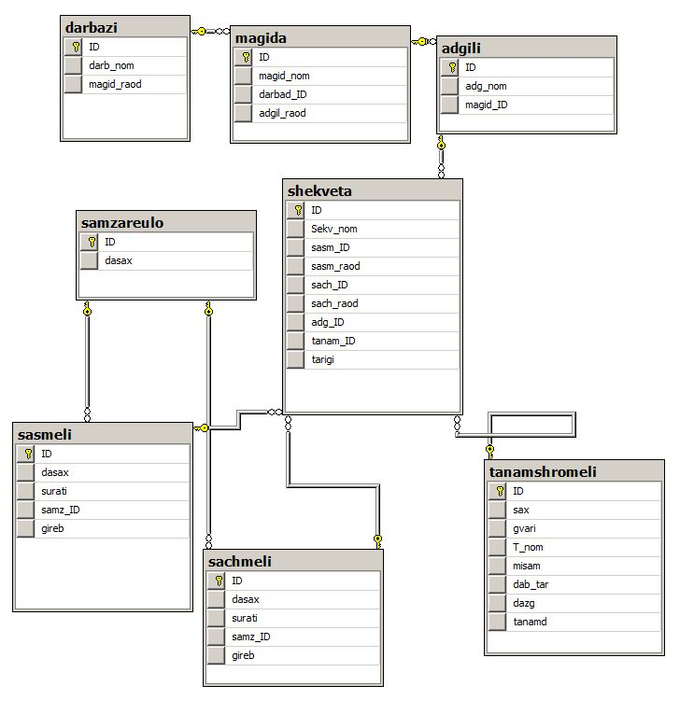

cxrilebis Sevseba:
darbazi:
USE restorani;
INSERT INTO darbazi VALUES ('1', '01','5');
INSERT INTO darbazi VALUES ('2', '02','4');
INSERT INTO darbazi VALUES ('3', '03','7');
INSERT INTO darbazi VALUES ('4', '04','10');

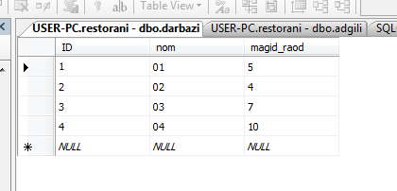

magida
USE restorani;
INSERT INTO magida VALUES ('1', '1','1','5');
INSERT INTO magida VALUES ('2', '2','3','5');

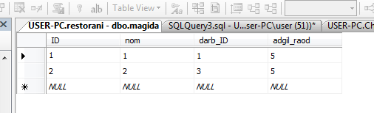

adgili
USE restorani;
INSERT INTO adgili VALUES ('1', '1','2');
INSERT INTO adgili VALUES ('2', '2','2');
INSERT INTO adgili VALUES ('3', '3','2');

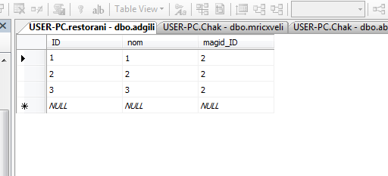

samzareulo

USE restorani;
INSERT INTO samzareulo VALUES ('1', 'qartuli');
INSERT INTO samzareulo VALUES ('2', 'berznuli');
INSERT INTO samzareulo VALUES ('3', 'italiuri');
INSERT INTO samzareulo VALUES ('4', 'franguli');

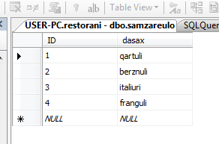

sasmeli
USE restorani;
INSERT INTO sasmeli VALUES ('1', 'xvanchkara', '1', '10');
INSERT INTO sasmeli VALUES ('2', 'glintveini', '2', '20');
INSERT INTO sasmeli VALUES ('3', 'viski', '3', '25');
INSERT INTO sasmeli VALUES ('1', 'punshi', '4', '35');

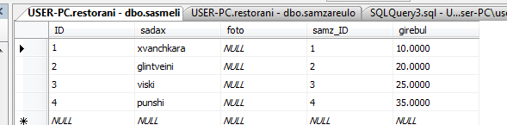

saWmeli
USE restorani;
INSERT INTO sachmeli VALUES ('1', 'sacivi', '1', '15');
INSERT INTO sachmeli VALUES ('2', 'pica', '3', '8.5');
INSERT INTO sachmeli VALUES ('3', 'ratatui', '4', '20');
INSERT INTO sachmeli VALUES ('4', 'tevsi', '2', '19.5');

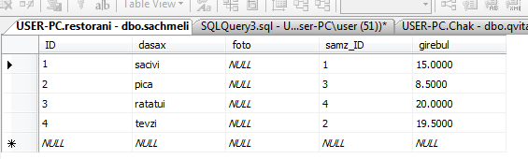

SekveTa
USE restorani;
INSERT INTO shekveta VALUES ('1', '1', '4', '3', '2', '2', '1', '4', '05.02.2013');
INSERT INTO shekveta VALUES ('2', '2', '1', '3', '3', '3', '2', '3', '07.03.2013');

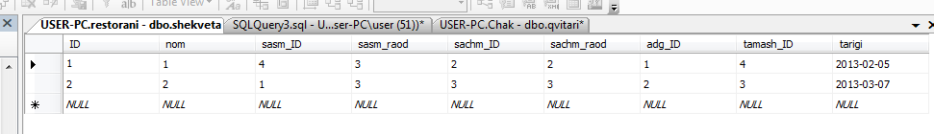

TanamSromeli
USE restorani;
INSERT INTO tanamshromeli VALUES ('1', 'nino', 'beridze', 'null', 'null', 'null', 'ki', ',menejeri');
INSERT INTO tanamshromeli VALUES ('2', 'teona', 'kiknadze', 'null', 'null', 'null', 'ki', ',bugalteri');
INSERT INTO tanamshromeli VALUES ('3', 'eto', 'chitadze', 'null', 'null', 'null', 'ki', ',iuristi');
INSERT INTO tanamshromeli VALUES ('4', 'salome', 'tabatadze', 'null', 'null', 'null', 'ara', ',mimtani');

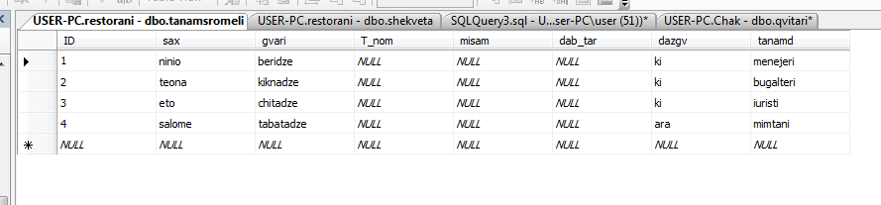

select brZaneba
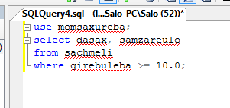
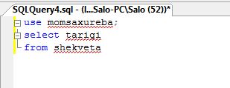

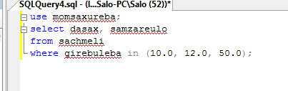

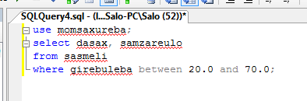

joinebi:

CROSS JOIN
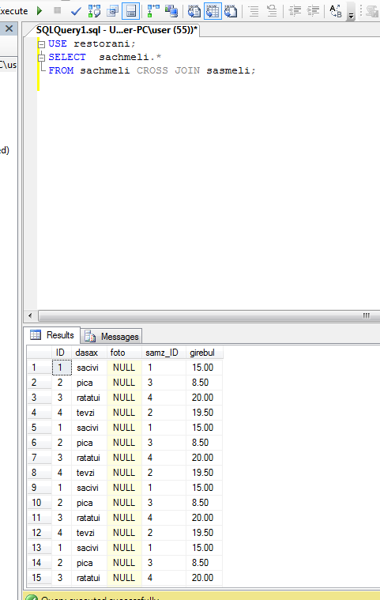

“Old-style” join:

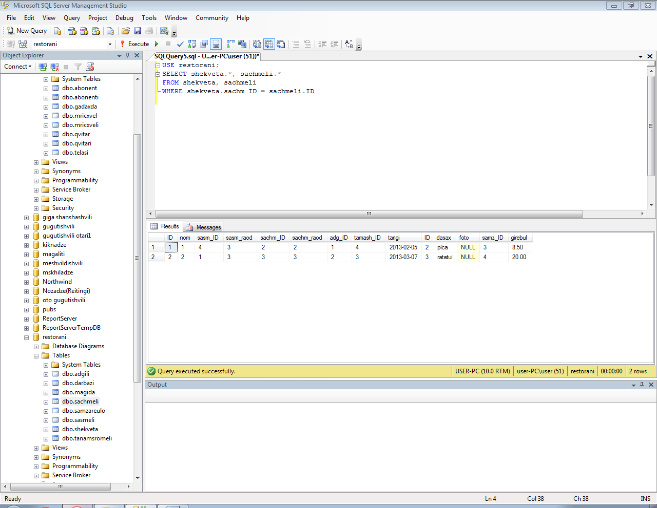

INNER JOIN

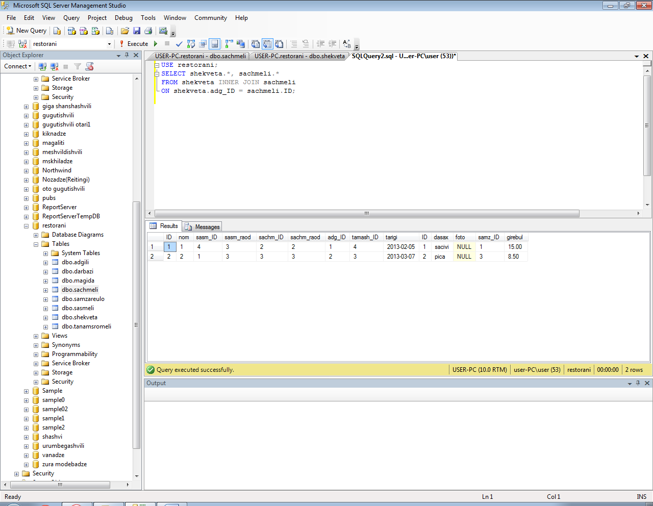

LEFT JOIN
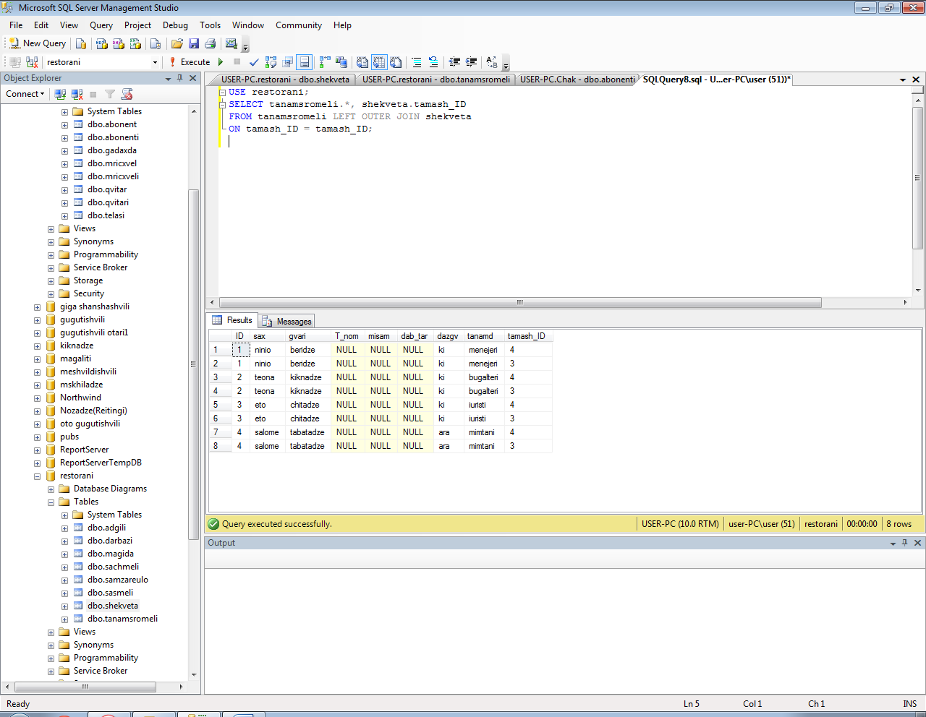

RIGHT JOIN

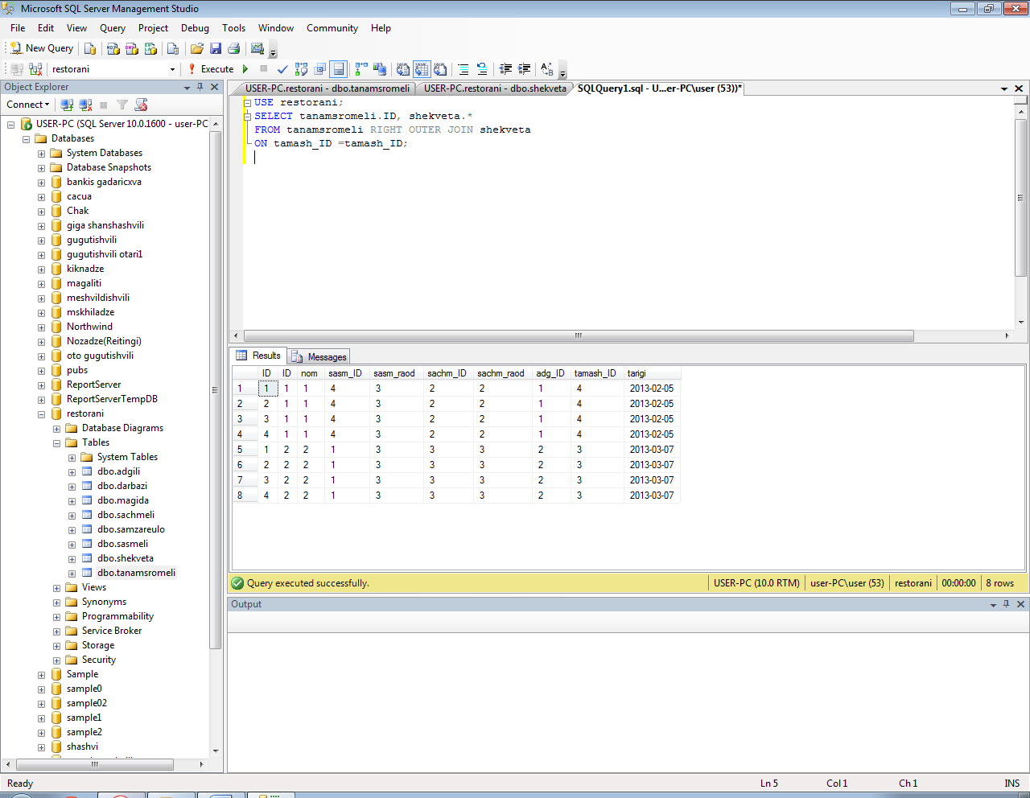

FULL JOIN
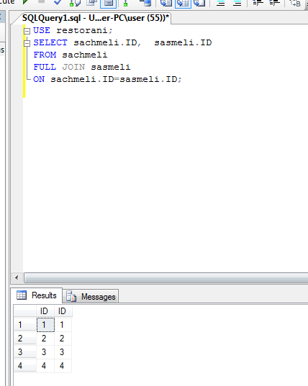

UNION

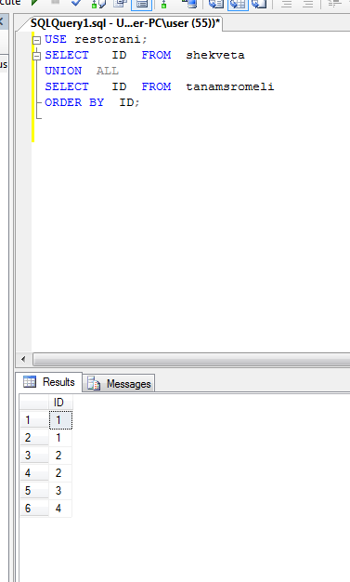

INTERSECT

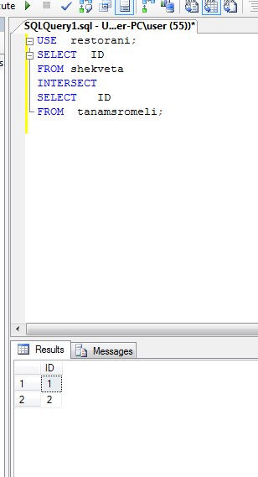

EXCEPT
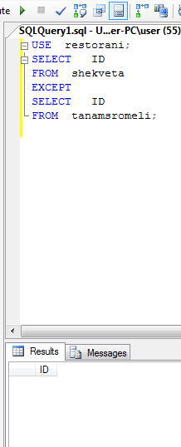

Senaxuli procedurebi:

